2018 AGRICULTURAL LAND USE REGULATIONS AND SPECIAL CONDITIONS

IOWA ARMY AMMUNITION PLANT (IAAAP), MIDDLETOWN, IOWA

- The lessee agrees to conduct all farming and grazing operations in accordance with the Land Use Regulations and Special Conditions set forth herein, and in accordance with the General Land Use Directives and the individual Tract Management Plan (Exhibit “C”).
- VERBAL AGREEMENTS WILL NOT BE HONORED. Any change in the Tract Management Plan, i.e., crop changes, maintenance requirements, etc., must be approved in writing by the Omaha District, Corps of Engineers, Real Estate Division, 1616 Capitol Avenue, Suite 9000, Omaha, Nebraska 68102-4901. Any such agreement will be finalized in writing in the form of a “supplemental agreement” to the lease or a letter from the Real Estate Contracting Officer.
- Lease operations are to be carried on within the limits of the Army Ammunition Plant area. The access, use and occupation of the premises leased shall be subject to the general supervision and approval of the officer having immediate jurisdiction over the property and such rules and regulations regarding ingress, egress, safety, sanitation, and security as may be prescribed by the officer.
- The Government maintains and uses utilities and facilities that are on or adjacent to the tract. The lessee will permit entry and performance of inspection(s) or maintenance as required.

- The lessee will plant a crop rotation as specified in the Tract Management Plan. All listed crop rotations must be adhered to. To change the crop rotation the lessee will submit a written request for approval by the IAAAP Agronomist. The IAAAP Agronomist may recommend changes due to adverse environmental factors that prevent planting the scheduled crop or to reduce the impact of a major pest infestation. All changes must be documented and accepted by the Real Estate Contracting Officer through a supplemental agreement or letter, as stated in Paragraph No. 2. Payment details can be found in the body of the lease contract.

All leased land will be planted prior to July 1st each year. To renovate alfalfa, winter wheat may be planted with written approval from the IAAAP Agronomist. The lessee should plan to direct seed/plant cover crops the same day the row crop is harvested.

The aerial application of cover crop seed is allowed per installation policy #33 (Exhibit “D”). Options to the listed cover crop types and establishment rates may be pre-approved in writing by the IAAAP Agronomist. The minimum required establishment rates are as follows: rye, oats and wheat 2 bushels per acre, vetch and clovers 10# per acre and turnips, rapeseed and radish 8# per acre. For failure to establish a required cover crop, a $60 per acre fee will be added to the next rental payment, as a condition of turn-in or as a condition of termination. Tillage of fall cover crops prior to 15 March is prohibited without prior written approval from the IAAAP agronomist.

- An annual fence inspection by the lessee on all grazing tracts is required. The lessee is responsible for maintaining all fences in the tract; except for the chain link fence(s). Prior to the turning in of livestock, the lessee will repair all required fences not in sufficient condition to contain or repel cattle. Any chain link fencing found not in sufficient condition to contain or repel cattle shall be reported to Guard headquarters upon discovery.

- The lessee will request permission to place structures on any tract. The location of structures will not interfere with plant operations or be within thirty (30) feet of a chain link fence.

The lessee will supply all equipment needed to water the cattle. The Government does not guarantee the quality or quantity of water. The grazing season is from the first Saturday in May to the first Sunday in November each year. Gates will not be opened to give cattle access to ponds that are fenced. The lessee, at the request of the IAAAP Agronomist, will gather all the cattle on the leased tract for counting. Should the number of animal units on the tract be more than allowed in the lease tract management plan, the lessee will remove the extra units within two days and the grazing period on the lease shortened for that year using the following formula. The number of extra units times 2 equals the number of days to shorten the grazing period. An animal unit is one bull or a cow/calf. Feeder calves and bred heifers are three quarters of an animal unit.

- The lessee will remove or lime dead cattle as soon as discovered. Cattle will not be buried on the installation. The lessee may be notified of livestock problems via telephone call or E-mail.

- Only Environmental Protection Agency approved pesticides will be allowed. EPA approved pesticides may be banned from use on Government property during the lease period. Should the EPA ban the production of a pesticide but not its use, the use of that pesticide on the installation will be prohibited. Safety Data Sheets (SDSs) (formerly MSDSs or Material Safety Data Sheets) for pesticides being applied will be carried in the field during application.

Prior to March 1st of each year, the lessee will provide the IAAAP Agronomist a pesticide use proposal (PUP) on the form provided. Pesticides listed in the PUP will not be applied until approved for use. Annually, by September 1st, the lessee shall submit a written report to the IAAAP Agronomist, detailing all chemicals applied during the year. (See attached PUP and Annual Pesticide Application Report) On or about September 1st, access to the installation will be denied for lessees who’s annual pesticide report has not been received.

The lessee shall assume full responsibility for applications of pesticides. Damage resulting from the use of pesticides by the lessee, either to the leased premises, adjacent property, and/or life shall be a lessee responsibility. Care will constantly be exercised in the mixing and usage of agricultural chemicals. Empty containers and excess material will be removed daily from the Installation.

- Pesticides with a high potential of carryover will not be used the last year of the lease.
- Pesticides will only be applied from a half-hour after sunrise to a half-hour prior to sunset.
- Pesticides will not be applied when wind the speed exceeds 10 miles per hour.
- The aerial application of any pesticide is prohibited.

- In the case of any chemical spill, call Guard Headquarters immediately at (319) 753-7414 or 7912. The lessee will incur the cost of cleaning up the spill and any regulatory fines associated with the spill.

- The leased tracts are subject to concurrent use for recreational purposes, including hunting, trapping and fishing, by such persons accorded the privilege by appropriate regulations established by the Installation Commander.

- Lessee and employees, visitors, or other personnel will comply with all Installation safety and security regulations and will be required to clear through the Installation security office prior to being permitted access to the Installation.

- The lessee will not enter any hazardous or explosive plant areas, including production lines and storage yards with vehicles equipped with catalytic converters. Converter equipped vehicles shall not be driven over or parked on a surface of easily combustible material such as straw, stalks, or dry grass.

- It is understood and agreed that the Government is not responsible for and will not reimburse the lessee for any crop damage sustained due to wildlife, maintenance activities, or any installation operation activities.

- REDUCED TILLAGE: After planting, no less than 25% of the ground will be covered by residue, except for the following reasons with IAAAP Agronomist approval: planting small grains or hay, grass waterway work, erosion repair, field tile and terrace work, testing of archeological sites and/or crop failure.

- CONSERVATION TILLAGE: After planting, no less than 30% of the ground will be covered by residue, except for the following reasons with IAAAP Agronomist approval: planting small grains or hay, grass waterway work, erosion repair, field tile and terrace work, testing of archeological sites and/or crop failure.

- FALL TILLAGE: Any vertical tillage deeper than 7" will only be allowed with the written approval from the IAAAP Agronomist. Light disking is approved for the planting of fall cover crops.

- NO TILLAGE: As described and defined by the Natural Resources Conservation Service, except for the following reasons with IAAAP Agronomist approval: planting small grains, cover crops, fallow seedings, grass waterway work, erosion repair, field tile and terrace work, testing of archeological sites and/or crop failure.

- The lessee will control noxious weeds. Noxious weeds will be controlled at or prior to the flowering stage. If the lessee fails to control noxious weeds within the lease tract and/or field borders, the Government, at its option, may have the noxious weeds controlled and the lessee shall immediately reimburse the Government for its incurred costs to control said noxious weeds.

- The lessee will be responsible for costs to repair damage to the installation, including signs and posts caused by lessee activities. All tractors actively involved in mowing activities will be equipped with rollover protection.

- Idle fields will be mowed annually by the lessee by August 1st.

Grazing leases will be mowed by August 1st of the first and third year of the lease period, unless stated otherwise in the individual Tract Management Plan.

The Government may mow for the lessee or terminate the lease if the lessee does not accomplish the mowing requirements in the lease. The present charge for mowing is about $90.00 per acre. This is not a fixed price and the price can change at any time without notifying the lessee prior to mowing. The lessee shall immediately reimburse the Government for incurred mowing costs.

- Lessees shall not plant row crops within the security clear zones of chain link fences. The clear zones are 30’ from the inside and 15’ from the outside of any chain link fence. Any crop within the clear zone may be mowed off at any time with the approval of the IAAAP Agronomist. Lessees that are found to have encroached upon a clear zone are required to re-establish grasses in those areas within 6 months. Lessees awarded new lease contracts will re-establish grasses in the clear zones during the spring of the first lease year to meet the distance requirements listed above.

- The Government plans to take soil tests, apply lime and fertilizer with the exception of nitrogen. The lessee will apply nitrogen (N) per the recommendations in the soil test results. The lessee will not apply more than 150 units of N per acre. Soil test and fertilizer data is public information. The application of Anhydrous Ammonia is only permitted during the months of March through July, unless proven necessary otherwise by a history of stalk testing. With prior written approval from the IAAAP agronomist, on an experimental basis, a limited amount of anhydrous ammonia may be applied during the month of November in conjunction with strip (Zone) tillage for the specific purpose of creating a 6” wide seed bed in preparation of spring planting. No additional tillage will be performed prior to spring planting. The lessee will pay for any lime and fertilizer applied by the Government as part of the annual rental payment due March 1st. These costs are likely to fluctuate and will be provided to the lessee as soon as they are available. Payment details can be found in the body of the lease contract.

- At no cost to the Government, the lessee will fix and or replace broken or missing tile intakes. The Government may require the lessee to repair up to two (2) tile blowout holes per tract per year, at the lessee’s expense.

- All new and/or existing grass waterways will not be sprayed with pesticides that could damage or kill the grass. All grass waterways will be left in sod if fields are cultivated. At the request of the IAAAP Agronomist, waterways will be created, removed, reseeded, mowed or changed as deemed necessary. Grass waterways will be maintained at least five (5) yards wide at the inlet and ten (10) yards wide at the outlet.

- The Lessee will not destroy native prairie or shelterbelt plantings. If these plantings are damaged or destroyed, the Lessee will be required to re-establish the planting at no cost to the Government. The lessee will control noxious weeds in the shelterbelt plantings that may border this tract.

- Crops will not be grown or tillage conducted within five (5) feet of the top of a back slope of a roadway ditch. The penalty for conducting a prohibited action listed above is $500 per Tract.
- All hay bales will be removed from the installation by March 1st each year.

- All row and hay crops will be mechanically harvested. Corn, soybeans and winter wheat will not be chopped nor will the stalks, stubble, straw, residue or stover be baled/removed from the leased acres. The row crop, small grain and cover crop residue is the property of the US Government. The only exception is spring oats when used as a nurse crop for alf alfa. The cutting and baling of hay on non-leased acres is prohibited. The penalty for conducting a prohibited action listed above is $250 per acre.

- Reference is made to Sketch NO. 067061-16, "Road Intersection - R.R. Grade Crossing Sight Requirements", which is included as part of this regulation. The lessee will take whatever measures are deemed necessary by the Commanding Officer to maintain acceptable sight distance requirements at intersections.

- Grazing is prohibited on tracts numbered under 100.

- Lessees will not store equipment on the installation. However, the lessee may leave equipment overnight in times of busy operations (planting, harvesting, etc.). The lessee may also leave equipment if the ground is too wet to move the equipment. The lessee must remove the equipment as soon as the ground dries up sufficiently to allow movement of the equipment. Cattle gates, panels and watering tanks may be left on grazing tracts during the lease term.

- Fuel supply tanks will only be parked in agricultural fields and parking lots not along roadways. Lessees are limited to a maximum of 500 gallons of supply fuel on post at any one time. All fuel supply tanks will be labeled with DOT placards 1993 or 1202 with fire symbol. All tanks shall be labeled with content and owner identification information.

- Annual rental payments are due prior to March 1st. On or about April 1st access to the installation will be denied for lessees who’s rental payment was not received by the U.S. Army Corps of Engineers prior to April 1st.

- ENVIRONMENTAL MANAGEMENT SYSTEM

Iowa Amy Ammunition Plant is committed to a high standard of environmental stewardship, and has implemented the ISO 14001 Environmental Management System (EMS) encompassing all activities within the installation.

All employees, contractors, lessees, visitors and tenants are required to conduct themselves in an environmentally responsible manner, including, but not limited to, the requirements set forth in the Agricultural Leases.

IAAAP environmental staff reserves the right to inspect contractor, lessee, visitor, and tenant activities for conformance to the requirements of the ISO 14001 Environmental Management System and to determine appropriate corrective action in the event of a nonconformance. It is the contractor’s, lessee’s, visitor’s or tenant’s responsibility to remedy any identified nonconformance associated with their activities.

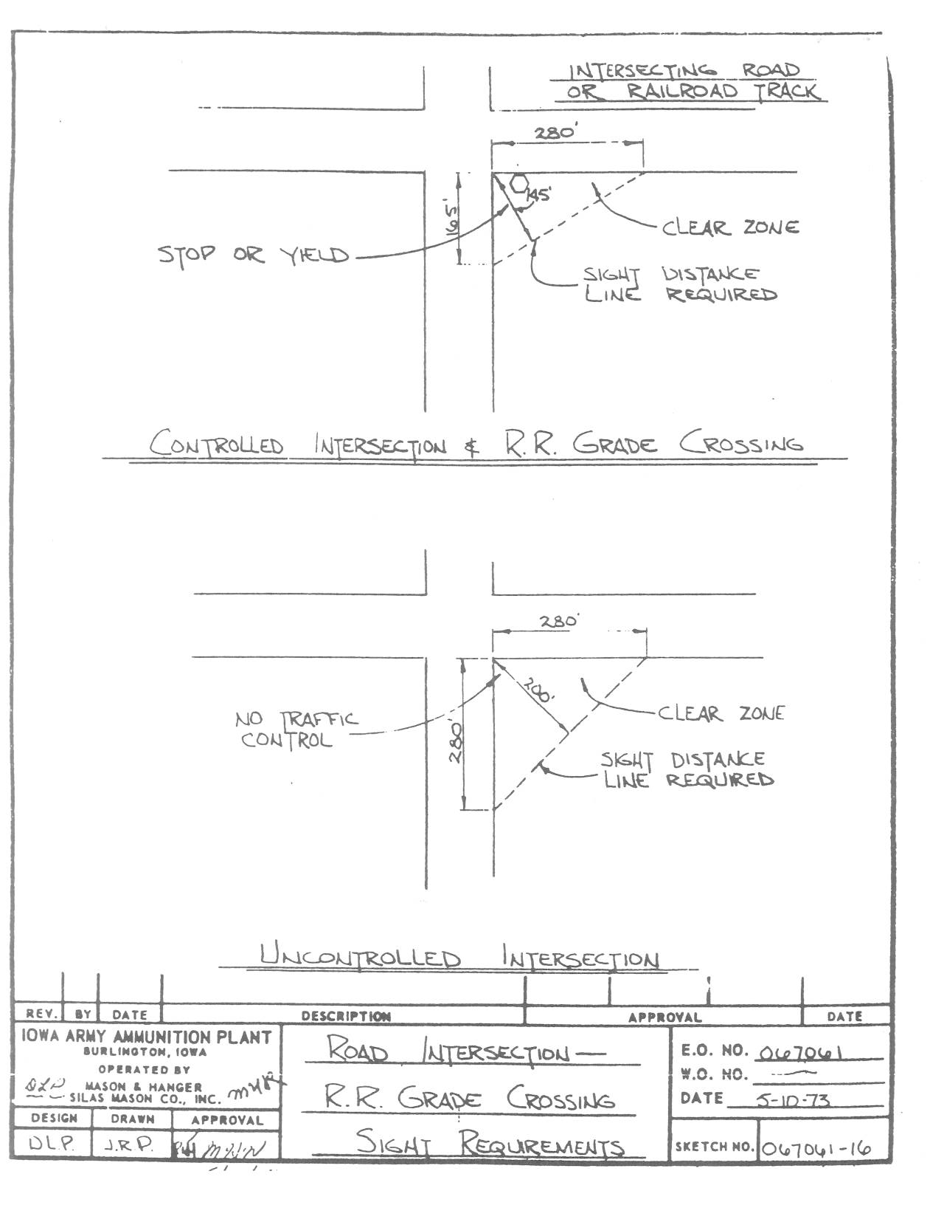
ANNUAL PESTICIDE USE PROPOSAL
Due By March 1st

NAME ________________________________
ADDRESS __________________________________________________________________
APPLICATOR (company/person) ________________________________________________
PESTICIDE: Certification #_________________Category_____________Exp. Date________

TRACT #________ (One Tract per Form) DATE_______________

PESTICIDE COMMON NAME | FEDERAL EPA REGISTRATION NUMBER | TYPE OF CROP AND TARGET PEST
Complete this report annually and return by March 1st. Pesticides listed in this form will not be applied until approved for use. The point of contact is Mr. Joe Haffner, Phone 319-753-7903 or Email joseph.j.haffner.civ@mail.mil.
ANNUAL PESTICIDE APPLICATION REPORT
Due by September 1st

NAME ________________________________
ADDRESS __________________________________________________________________
APPLICATOR (company/person) ________________________________________________
PESTICIDE: Certification #_________________Category_____________Exp. Date________
TRACT #________ (One Tract per Form) DATE_______________

PESTICIDE COMMON NAME AND FEDERAL EPA REGISTRATION NUMBER | TYPE OF CROP AND NUMBER OF ACRES APPLIED TO | TOTAL AMOUNT OF PRODUCT APPLIED
Complete this report annually and return by September 1st. On or about September 1st, access to the installation will be denied for lessees who’s annual pesticide report has not been received. The point of contact is Mr. Joe Haffner, Phone 319-753-7903 or Email joseph.j.haffner.civ@mail.mil.

