DESCRIPTION of PROPOSED ACTION and ALTERNATIVES:

MODERNIZATION of MELT POUR OPERATIONS

at

IOWA ARMY AMMUNITION PLANT (IAAAP)

May 2, 2017

TABLE OF CONTENTS

1.0 Purpose And Or Need For The Proposed Action 3
1.1 Introduction 3
1.2 Purpose and Need 3
2.0 Description of proposed action and alternatives 4
2.1 Proposed Action 4
2.2 Screening Criteria 4
2.3 Alternatives Eliminated From Further Consideration 4
2.4 Alternatives Considered 4
2.4.1 Tasks Common among Alternatives 4
2.4.2 Alternative 1: Move Line 3A Melt Pour and LAP Capabilities to Location A (Preferred Alternative) 5
2.4.3 Alternative 2: Move Line 3A Melt Pour and LAP Capabilities to Location B 5
2.4.4 Alternative 3: Move Line 3A Melt Pour and LAP Capabilities to Location C 5
2.4.5 Alternative 4: Move Line 3A Melt Pour and LAP Capabilities to Location D 5
2.5 Alternative 5: No Action Alternative 6

FIGURES and TABLES
Figure 1: Aerial Photograph of IAAAP
Figure 2: Locations of Alternatives for Footprint Consolidation and Environmental Remediation Areas
Table 2-1: Screening Criteria

1.0 Purpose And Or Need For The Proposed Action

1.1 Introduction
The Iowa Army Ammunition Plant (IAAAP) is located in Middletown, IA and consists of 19,011 acres in Des Moines County. IAAAP is a Government-Owned, Contractor-Operated (GOCO) production facility under the command of Joint Munitions Command and Army Materiel Command. Funding for the modernization of the facility is provided through the Project Director for Joint Services (PDJS). American Ordnance, LLC (AO) is the operating contractor at IAAAP. IAAAP is the primary organic load, assemble and pack (LAP) facility for large caliber ammunition in the National Technology and Industrial Base (NTIB). IAAAP’s core production capabilities are LAP for a full range of munitions, tank ammunition, high explosive artillery, large caliber mortars, insensitive munitions, pressed and cast warheads, missile assembly, rocket assisted projectiles and detonators. The Army is proposing to upgrade current infrastructure and construct a new melt pour production facility on the eastern portion of IAAAP which will employ modern and more efficient LAP technologies.

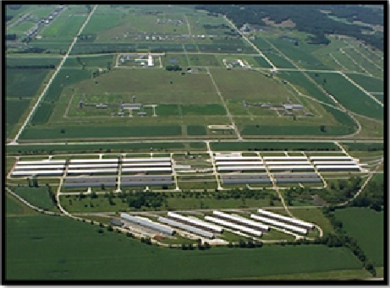
Figure 1. Aerial Photograph of IAAAP

1.2 Purpose AND NEED
The purpose of the proposed action is to modernize and consolidate LAP operations at IAAAP into the eastern portion of the installation. The proposed action is needed in order to maintain IAAAP’s munitions production capability in a cost-effective, energy efficient, and environmentally preferable manner.

Production facilities at IAAAP were built in the 1940’s are beyond their designed service life and are costly to maintain. The current operational footprint at IAAAP spans19,011 acres, which does not allow for efficient movement of materiel across the facility and requires the costly maintenance of an expansive utility infrastructure. The construction of a modernized melt pour facility closer to existing production facilities on the eastern portion of IAAAP will facilitate logistical and operational efficiencies. The construction and updating of associated infrastructure will be necessary to improve operations and accommodate the new production facility. Specifically, consolidation and modernization of LAP operations at IAAAP will: (1) reduce production costs, (2) reduce production cycle times, (3) reduce maintenance costs, (4) reduce energy costs, and (5) reduce waste generation. Failure to upgrade, or executing significant modifications to the existing facilities, will impact long-term and near-term mission readiness in the form of production shutdowns. Without modernization, LAP operations at IAAAP will become prohibitive due to environmental, safety or cost factors, and the Army will become unable to meet production demands.

2.0 Description of proposed action and alternatives

2.1 Proposed Action

The proposed action is the construction and operation on the eastern portion of IAAAP of a new melt pour facility, as well as the construction of new and/or modernization of existing support infrastructure as needed to support IAAAP’s current and anticipated future LAP production requirements.
If the Army decides to proceed with the proposed action, the Army will determine when the project can be funded. If implemented, the proposed action will consist of a 12 month design phase expected to begin in FY18, followed by an approximately 24 month construction phase.

2.2 Screening Criteria

Screening criteria (Table 2-1) have been developed to further identify only viable alternatives to achieve the purpose and need for the proposed action. For an alternative to be considered viable and carried forward for analysis, it must meet the purpose of, and need for, the proposed action as well as satisfy the following screening criteria:

Table 2-1: Screening Criteria
Available Space | Suitable construction areas must have sufficient space to accommodate a new melt pour facility; and as required, ancillary support structures; and be located in close proximity to existing support infrastructure, such as steam lines, utilities, roads and rail lines.
Non-interference with Installation Restoration Program (IRP)/Military Munitions Response Program (MMRP) Sites | Construction areas will be reviewed to ensure that there is no adverse impact on IRP or MMRP response objectives or existing land use restrictions.
Explosive Safety/Quantity Distance (QD) Arcs | Explosive safety arcs show the influence of potential explosions from buildings containing explosives. The arc for the new modern melt pour production area must not impact other arcs, or mission critical buildings.

2.3 Alternatives Eliminated From Further Consideration

After application of the screening criteria referenced in Paragraph 2.2 above, several areas were eliminated as alternative construction sites for the melt pour production area, and were therefore eliminated from further consideration. Only the alternatives listed in Section 2.4 will be carried forward for evaluation as to their potential environmental impacts.

2.4 Alternatives Considered

2.4.1 Tasks Common among Alternatives
- The new melt pour facility will be located outside QD Arcs, and the facility will be constructed close to utilities (within approximately one mile) in order to make use of existing utilities infrastructure.
- The constructed facility will be located and oriented to maximize access to, and use of, existing road and rail infrastructure; as well as to minimize the construction of new road or rail infrastructure.
- Installation, upgrading, re-routing and/or removing current road, rail, water, sewer and electrical infrastructure may be required for the new facility or to provide access to existing infrastructure.
- The alternatives may involve the relocation and/or consolidation of additional capabilities; such as the relocation of usable equipment in the existing melt pour facility or the consolidation of equipment or capabilities within buildings in the vicinity of the new melt pour facility.
- Demolition of existing structures may be necessary under the alternatives.
- Projects that could be required under the alternatives include:
  - Upgrading existing roads or creating new roads that will allow access to the new location. Constructing new roads could result in land being disturbed (i.e. mowing, tree removal etc.).
  - Upgrading existing rails or constructing new rail infrastructure that will allow access to the new location. The creation of new rails could result in land being disturbed (i.e. mowing, tree removal, culvert repair/replacement etc.).
  - The re-routing and/or installation of new gas, steam, water, sewage and/or electrical infrastructure. These projects may result in land being disturbed. Digging may also be required to install the infrastructure for the utilities.
  - Installation of distributed natural gas boilers. The natural gas boiler system will be used for steam generation and comfort heat at the new facility.

2.4.2 Alternative 1: Move Line 3A Melt Pour and LAP Capabilities to Location A (Preferred Alternative)
Under the Preferred Alternative the melt pour facility, about 240,861 square feet, would be constructed and operated within the eastern portion of IAAAP, within the vicinity of the location depicted as Location A in Figure 2.
- Approximately 4 miles of existing roads may require upgrading under this alternative. Approximately 5 miles of new roads around the new facility and accessing existing roads may also be needed.
- Approximately 16 miles of existing rail may require upgrading under this alternative. This would include approximately 11 miles of rail providing access to the line and approximately 5 miles of rail within the production line.

2.4.3 Alternative 2: Move Line 3A Melt Pour and LAP Capabilities to Location B
Under this Alternative the melt pour facility, about 240,861 square feet would be constructed and operated on the east side of IAAAP, within the vicinity of Location B in Figure 2.
- Approximately 3 miles of existing roads may require upgrading under this alternative. Approximately 5 miles of new roads around the new facility and accessing existing roads may also be needed.
- Approximately 12 miles of existing rail may require upgrading under this alternative. This would include approximately 7 miles of rail providing access to the line and approximately 5 miles of rail within the production line.

2.4.4 Alternative 3: Move Line 3A Melt Pour and LAP Capabilities to Location C
Under this Alternative, the melt pour facility, about 240,861 square feet, would be constructed and operated on the east side of IAAAP, within the vicinity of Location C in Figure 2.
- Approximately 3 miles of existing roads may require upgrading under this alternative. Approximately 5 miles of new roads around the new facility and accessing existing roads may also be needed.
- Approximately 13 miles of existing rail may require upgrading under this alternative. This would include approximately 8 miles of rail providing access to the line and approximately 5 miles of rail within the production line.

2.4.5 Alternative 4: Move Line 3A Melt Pour and LAP Capabilities to Location D
Under this Alternative the melt pour facility, about 240,861 square feet, would be constructed and operated on the east side of IAAAP within the vicinity of Location D in Figure 2.
- Approximately 7 miles of existing roads may require upgrading under this alternative. Approximately 5 miles of new roads around the new facility and accessing existing roads may also be needed.
- Approximately 20 miles of existing rail may require upgrading under this alternative. This would include approximately 15 miles of rail providing access to the line and approximately 5 miles of rail within the production line.
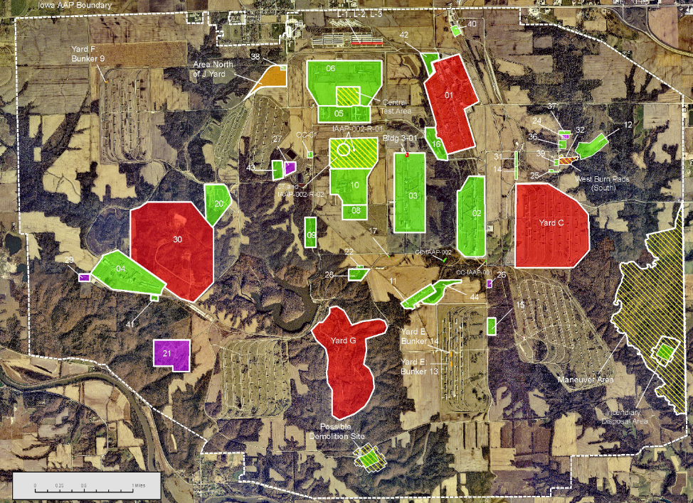
D
C
BB
Move Line 3A to East-Side (Location TBD)
A
Figure 2. Locations of Alternatives for Footprint Consolidation and
Environmental Remediation Areas
GREEN= IRP Site, RED=MMRP Site PURPLE=Compliance Cleanup Site ORANGE=FUSRAP Screening Site

2.5 Alternative 5: No Action Alternative
CEQ regulations require analysis of a No Action Alternative in order to provide a benchmark, enabling decision makers to compare the magnitude of the potential environmental effects caused by the other alternatives considered to implement the proposed action. The No Action Alternative is not required to be reasonable, nor does it need to meet the purpose and need described in Section 1.2. Under the No Action Alternative the melt pour facility would remain at its current location and there would be no new melt pour facility constructed or modernization of associated infrastructure initiated. The no action alternative is inefficient and is not consistent with feasible long-range mission readiness objectives. The no action alternative will be costly to maintain, will not effectively meet federal mandates and standards for energy efficiency and waste minimization, and will make it difficult for the Army to meet current and future production requirements.

